**Arduino Nano**

**Pinout:**

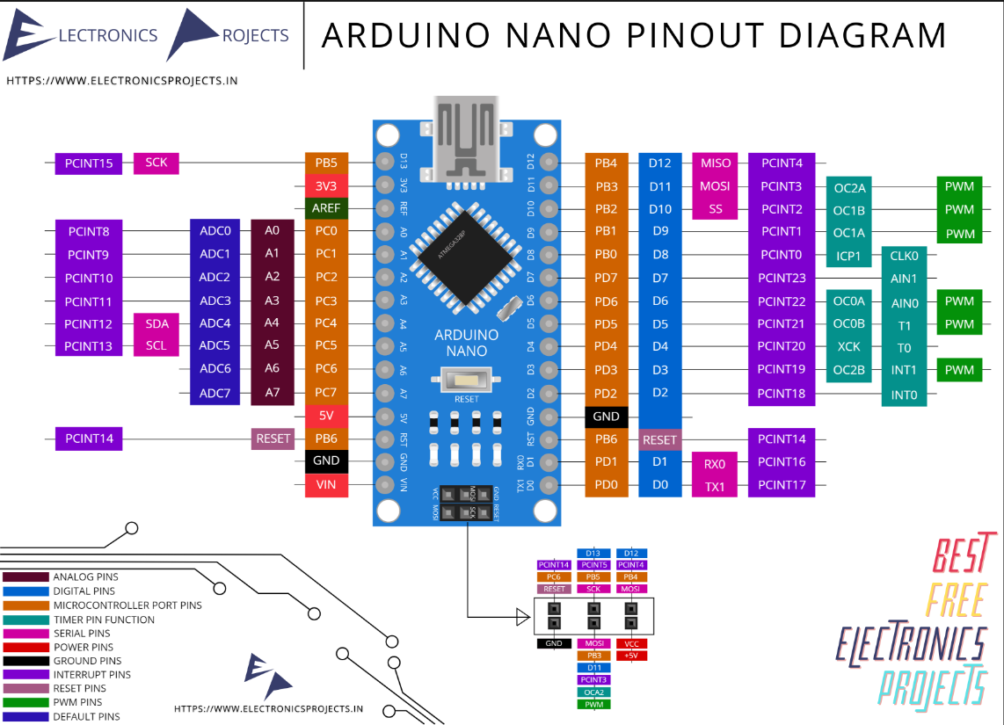

The Arduino Nano is a compact and versatile microcontroller board that is part of the Arduino family. Here are the key details about the Arduino Nano:

**Microcontroller:**

The Arduino Nano is based on the Atmel ATmega328P microcontroller. It operates at a clock speed of 16 MHz.

**Memory:**

Flash Memory: 32 KB of which 2 KB is used by the bootloader.

SRAM: 2 KB

EEPROM: 1 KB

**Operating Voltage:**

The Arduino Nano operates at 5V.

**Input Voltage:**

The recommended input voltage for the Arduino Nano is 7-12V.

**Digital I/O Pins:**

The Arduino Nano has 22 digital input/output pins (of which 6 can be used as PWM outputs) and 14 analog inputs.

**PWM (Pulse Width Modulation):**

The Nano has 6 PWM outputs, available on pins D3, D5, D6, D9, D10, and D11.

**Analog Inputs:**

The Nano provides 14 analog input pins (A0 to A13).

**Communication:**

UART, SPI, and I2C communication interfaces are available on the Nano.

**USB Connector:**

The Nano uses a mini-USB connector for programming and communication with a computer.

**On-board Components:**

The Nano includes a built-in LED connected to digital pin 13.

It has a reset button for restarting the microcontroller.

**Programming:**

The Arduino Nano can be programmed using the Arduino Software (IDE), which supports the C and C++ programming languages.

It can be programmed via a USB connection to a computer.

**Size:**

The Nano is compact in size, measuring approximately 18.5 x 43 mm.

**Bootloader:**

The Arduino Nano comes with a pre-loaded bootloader, making it easy to program via the Arduino IDE.

**Power Supply:**

The Nano can be powered using an external power supply connected to the Vin pin or through the USB port.

**Compatibility:**

The Arduino Nano is compatible with most Arduino shields and can be used in various projects, especially those with space constraints.

**Variants:**

There are different variants and clones of the Arduino Nano available in the market, with slight variations in features and form factors.

The Arduino Nano is popular for projects where a small form factor is essential, and it offers a balance of features suitable for a wide range of applications, including robotics, electronics prototyping, and educ2ational projects.

The Arduino Nano has a variety of pins that serve different purposes. Here's an overview of the main pins on the Arduino Nano:

Digital Pins:

**Digital Pins (D0 - D13):**

These pins can be used as digital input or output.

D3, D5, D6, D9, D10, and D11 support PWM (Pulse Width Modulation).

**PWM Pins (Pulse Width Modulation):**

D3, D5, D6, D9, D10, and D11 can generate PWM signals.

**Analog Pins:**

Analog Pins (A0 - A5):

These pins can be used to read analog voltage levels (0 to 5V).

The Arduino Nano has a total of six analog input pins (A0 to A5).

**Power Pins:**

**Vin:**

This pin can be used to supply an external voltage (7-12V) for powering the Arduino Nano.

**5V:**

This pin provides a regulated 5V output.

**GND (Ground):**

Ground pins for reference.

**3V3:**

A 3.3V output pin.

**Communication Pins:**

TX (Transmit) and RX (Receive):

These pins are used for serial communication.

RESET:

This pin is used to reset the microcontroller.

External Interrupts:

D2, D3:

These pins (INT0 and INT1) can be used for external interrupts.

I2C Communication:

A4 (SDA) and A5 (SCL):

These pins are used for I2C communication.

SPI Communication:

D10 (SS), D11 (MOSI), D12 (MISO), D13 (SCK):

These pins are used for SPI communication.

AREF (Analog Reference):

AREF:

Analog Reference pin.

USB Connection:

USB Connector:

The mini-USB connector is used for programming and communication with a computer.

Built-in LED:

Built-in LED:

Connected to digital pin 13, this LED is often used for simple visual feedback in programs.